
PARISH NEWS
The Deverills & Crockerton

St Michael the Archangel, Brixton Deverill
by Pat Armstrong

June 2010

Look inside for local information

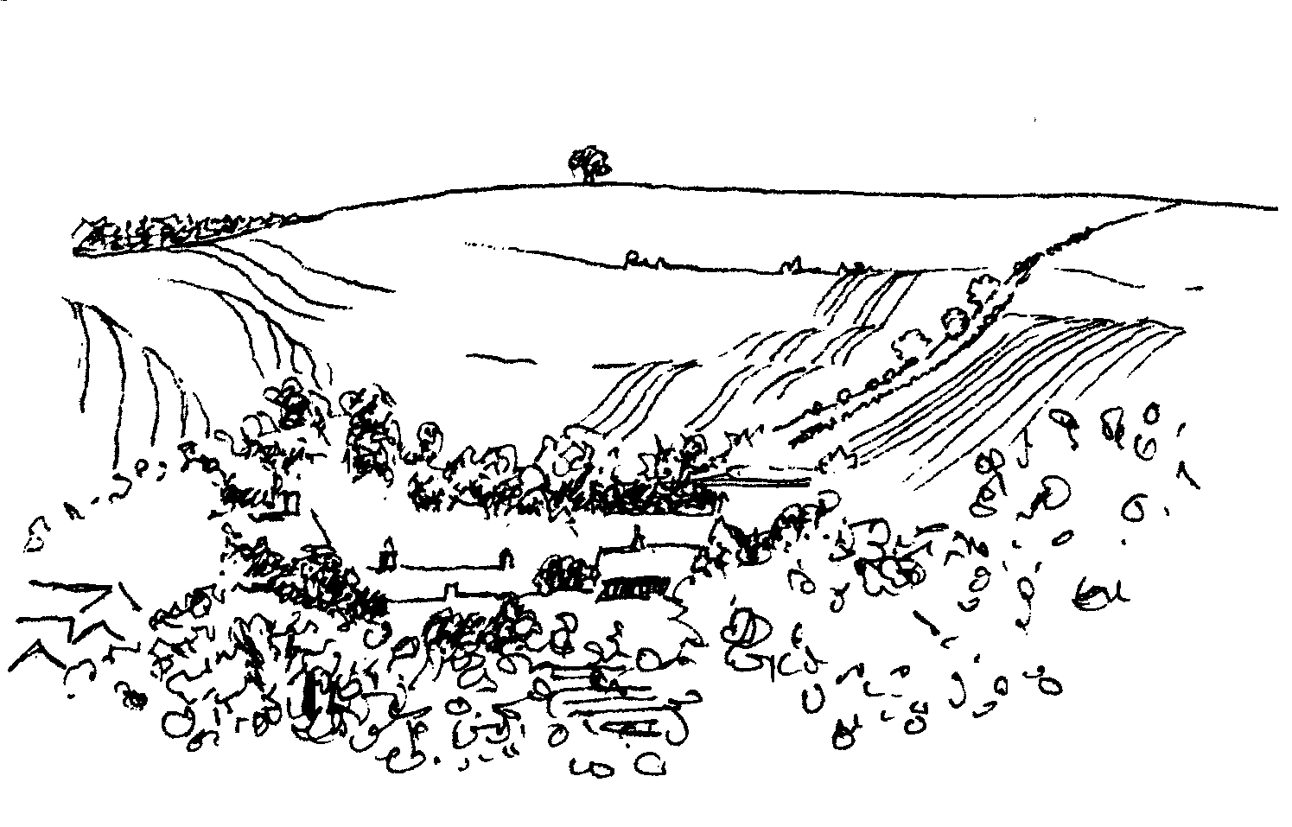
-2-

An invitation to another SCRABBLE TEA
Friendly fun afternoon for anyone, beginners or addicts!
Draw for partners at 2.00 pm on Wednesday 2nd June
Longbridge Deverill Village Hall
Admission £3.00 for 2 games, prizes, raffle, afternoon tea
Please call Ruth (212415) or Jill (840209)
The surplus monies from this event are for the
Wilts Air Ambulance

Farm Walk - Sunday 4th July
Manor Farm, Kingston Deverill from 2.00 pm onwards
Walking in groups on the Downs - about 2 miles
Stopping to discuss farming, wildlife and other issues
Dogs welcome, on leads please
Tea will be provided - Adults £5.oo - Children free
Enquiries please call 844549
All proceeds divided between The Deverills Churches and Help for Heroes.
Enquires 01985 844549

Coffee, Cards and Chat
Come and enjoy looking at the new range of cards,
ribbons, wrapping paper, and other exciting items
displayed by John and Maddie Goodden
in the Upper Deverills Village Hall on Thursday 19th February
between 10.30 and 12.00 noon - everyone is welcome
Donations will be made to the hall and the church

CROCKERTON VILLAGE COMMITTEE
Summer Party
10th ANNIVERSARY CELEBRATION
MILLENNIUM PEACE GARDEN (By School)
Sunday 4th July from 3.00 pm
3.30 pm original committee photograph, 4.00 pm tea & cakes on the Green (school open in the event of inclement weather) EVERYONE WELCOME

Parish Lunch
In a Marquee on the Cricket Field at Kingston Deverill
Sunday 11th July
12.30 pm for 1.00 pm
Please bring your own drinks & glasses
Adults £10.00, Children £5.00
Proceeds will go to Church Funds
Tickets: Sylvia Titt 214825 or Janet Budgen 218203

-3-

The Rector writes:
To my surprise, I found the political situation following last month’s General Election rather compelling. Listening to conversations and comment about the developing situation was thought provoking, especially in the light of the election campaign. Dare I say, it was even quite exciting!
Two ideas fought for attention in my mind. First, I was struck by the similarity between the intention of the leaders in the coalition and couples about to be married. Everything is going to progress wonderfully. Nothing is going to come between us. Promises made will endure. No challenge will upset the intention to strive together for the best future possible. Things might get tough, but we will win through! Long may that last!
Secondly, I found myself pondering about qualities of leadership. In what sort of person is it possible to have confidence? How should ‘leaders’, political, industrial, legislative, religious, health-care, or educational, exercise the responsibility which is theirs? Sometimes it might seem easy to submit to a dictatorial style, but where is the freedom in that? Choices are removed and responsibilities off-loaded. To leaders who enable and empower, responses will be more positive.
For me, it is Christ himself who exemplifies qualities of leadership to which all could well aspire. He was perhaps the first ‘non-conformist’, but had enormous compassion, followed his vocation with determination and resolve, spoke challengingly when necessary, taught and illumined understanding in a new way, all within the reconciling love of God. He led by example as much as by instruction. He demonstrated leadership qualities in the very way he lived. Somehow it didn’t matter that he did not fit expectations.
Whatever our views, our politicians have a challenging time ahead. And so, I think, do we!
Norma Payne
A note about Bishop David
Bishop David Stancliffe retires in September, his last official engagement being the Ordination of Deacons on Saturday 3rd July (11.00 am in the Cathedral). Following that service, everyone is invited to picnic on the cathedral green. The Bishop wants his leaving gift to support Bishop Gwynne Theological College in Sudan, cheques payable to Salisbury DBF ‘Bishop David’s Sudan Appeal’ may be sent to Church House, Crane Street, Salisbury, SP1 2QB.
If each electoral roll member in the diocese gave £2.50 the target amount of £66,000 would be achieved. Gift Aid your donation if you are a taxpayer. Thank you.
Christian Aid
Thank you to everyone who supported the Christian Aid week in May by making donations into Christian Aid envelopes and by attending and donating to the Coffee Morning Bring & Buy at the Rectory. The amount raised in the parish this year was £461.60, which the charity will be very grateful to receive.

-4-
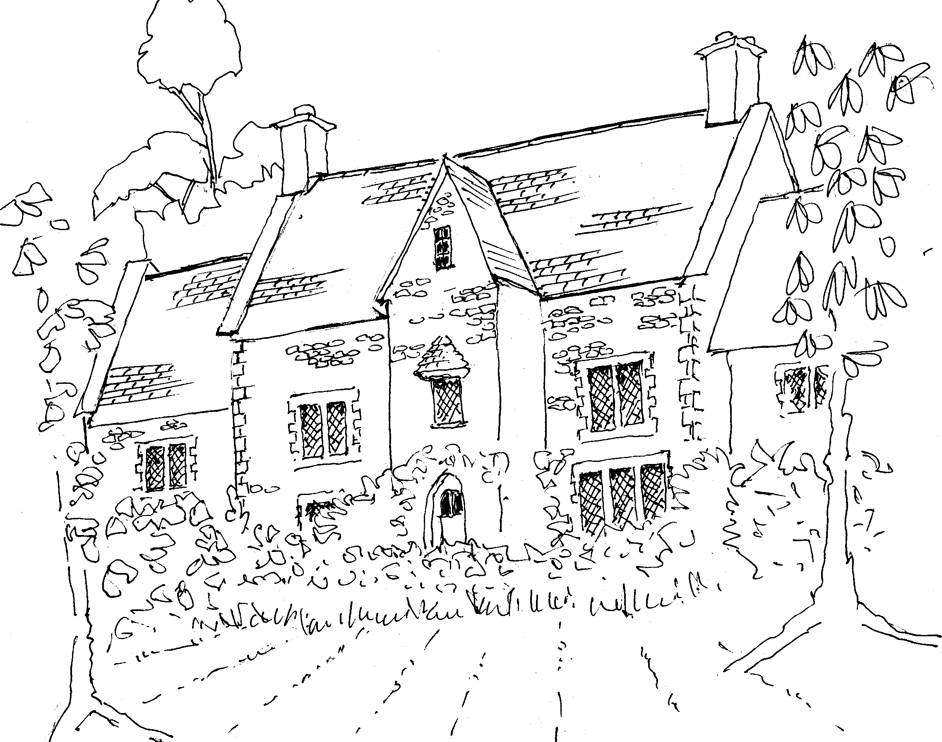


Athenaeum Singers
Featuring professional soloists
Saturday 19th June 7.00 pm
The Minster Church, Warminster
The powerful and dramatic re-telling by Mendelssohn
of the Old Testament story of Elijah
Tickets: £12.50 from the choir or Warminster Information Centre or Ann Coventry on 213594
www.athenaeumsingers.com

♫ MUSIC RECITAL ♫
Reading Rooms, Corsley
Registered Charity No: 1020542
Saturday 19th June at 7.30pm
Tickets: £10 Buffet Supper & Licensed Bar
A Summer Evening with 4Play Woodwind Quartet
Enjoy a relaxing, gentle evening of beautiful classical and modern music arranged specifically for an unusual combination of 2 flutes, oboe & clarinet
Tickets: Rosemary Collins, 01373 832789, and Committee Members

Unwanted saleable treasures in the attic? Then come to
BARGAINS IN THE BARN
Saturday 19th June, High House Farm, Corsley
£10 per table (to local Churches) Make some cash in the cowshed’
Enjoy a fun afternoon from 2.00 – 4.00 pm, light refreshments available
Entry £1, table-holders free
Contact Judith Helliar 01373 832803
National Gardens Scheme
Job's Mill, Crockerton, Wiltshire BA12 8BB
Sunday 6th June 2.00 - 6.00 pm
Refreshments: Home-made teas
Admission: Adults £3, children free
Location: 1½m S of Warminster, down lane E of A350, S of A36 r'about
A converted water mill, with terraced garden through which R Wylye flows Riverside and woodland walks

-5-

Refurbiz
The Domestic Appliance Re-cycling Charity
Refurbished appliances at affordable prices with warranty

Replacing your washing machine, dryer, fridge, electric cooker?
Please donate your old machines to us
so we can refurbish them for families in need

Wiltshire-wide collection and delivery service
Call 01380 720200, or visit our showroom at Hopton Park, Devizes
www.refurbiz.org Registered Charity Number 1107150

Salisbury Women’s Refuge
Thank you for all the wonderful donations recently received for our families here at the Refuge. I can honestly say that your support certainly makes a huge difference to the level of service we are able to offer, for which we can not thank you enough. In this economic climate, without your continued support, we would certainly struggle to maintain the level of service we have, which is down to you. We are always very grateful for children’s clothing, single duvets and sheets. I give our sincere thanks to all those who have supported us over many years.
Sally Booth – Refuge manager
Wiltshire’s Bobby Van Trust
Anyone who is unfortunate enough to be a victim of a break in or distraction burglary in Wiltshire and Swindon, especially if they are over 60 years old, will be referred to Wiltshire’s Bobby Van Trust. Once a referral has been made, the Trust will always make an appointment to visit the home, they will never cold call. Officers are able to give advice regarding the incident and most importantly how to prevent being re-victimised. They provide not only practical help, for instance installing door chains and viewers, but also give the elderly person real reassurance that not only are they being taken seriously but that there are people around who will help them. Bobby Van officers are all Home Office qualified crime reduction officers and Wiltshire Fire and Rescue trained fire risk assessors. They are also all skilled carpenters and lock fitters.
The Trust was set up in 1998; it is a registered charity and completely responsible for raising its own funds. The service is free for older, vulnerable and disadvantaged people. The Trust is often asked to attend societies and groups to give talks mainly to older people about how they can increase their safety and prevent distraction burglary. An example of a recent talk was to Kennet Valley 60+ group which 34 members attended. During 2009/10 to date, Wiltshire’s Bobby Van Trust in Wiltshire and Swindon has visited 75 homes which were targeted by distraction burglars and three homes which had bogus callers.

-6-

Tennis Coaching
A group of ‘girls’ meet at the Warminster courts at 9.30 am on Tuesdays for coaching. If you are interested in joining us please contact Judith Hirons 845255.
The Deverills Cricket Club
Home matches take place on the cricket ground next to the Upper Deverills Village Hall starting from 2.00 or 2.30 pm, please do come along to watch and support us. The home fixtures are on:
6th, 13th & 27th June, 4th & 25th July,
1st, 22nd, & 30th August, 12th September
If you would like to join the club and require further information please call Peter Child on 01963 34593 or Jamie Fagan on 844123 / 07796 698180.
Pilates in the Deverills
A beginners' class has started in Kingston Deverill Village Hall on Thursday mornings. There is an opportunity for an additional class at 10.15 - 11.15 am on a Thursday. The first session would be on 10th June and will run to the 22nd July, breaking for the school summer holidays. If anyone is interested please contact Emma Healey by email at healeydel@aol.com or by her mobile on 07929 517474. I can thoroughly recommend the classes!
Penny Marsh 840828
Deverill Valley & Crockerton Women's Institute
Our meeting this month will be Monday 14th June at 7.30pm at Longbridge Deverill Village Hall when Mr B Ducker will speak and answer questions on a Prison Officer's View of Life in Prison. This will be followed with tea and biscuits and a raffle. If you would like to know more about the WI in the Deverill Valley please contact Julie Wallder on 213142. You would be very welcome to join our meetings.
Attention History Lovers!
To commemorate the start of WW1 the Codford & Local History Society cordially invite anyone interested in history to join a small group investigating the effect on their parish during the war of the encampments in the Valley. We need volunteers especially from Sherrington, Fisherton de la Mere, Sutton Veny and Longbridge Deverill to help prepare an exhibition in August 2014. Possibly interested? Please do call in the first instance either Barbara (850247) or Richard (850822) and see what they have already got on Boyton and Corton.

-7-
Save the Children 2010
Cream teas and garden open in aid of Save the Children

This will be held at Mill Farm, Hill Deverill on Sunday 27th June from 3.00 pm - 6.00 pm (and on the last Sunday of the following three months). There will be cakes and plants for sale as well as other interesting items. Come and enjoy a relaxing afternoon in the barn or garden.
Anne Hurd
Longbridge Deverill Village Hall
The St George’s Day lunch held at the village hall was once again a great success. Approximately 45 people enjoyed a very patriotic day and a lunch of delicious stew and dumplings followed by a great choice of scrummy apple pies etc. with ice cream. Huge thanks go to the committee who produced the excellent food and to Magi who organised the decoration of the hall. Also, thank you to the people who donated raffle prizes, and those who stayed to help clear up. We made a profit of £358 towards the Hall Fabric Fund.
Our next event is a Quiz night on Saturday 17th July
Upper Deverills Village Hall
Rounders and Barbecue - Thursday 17th June at 6.30 pm
Due to a match of interest in the World Cup, the Rounders evening will now take place on Thursday 17th June and not Friday 18th June as originally planned. This annual event is held on the cricket field next to the Upper Deverills Village Hall. It is a good excuse for a convivial community evening in the summer sunshine. As usual, a barrel of local beer will be provided to accompany the delicious barbeque.
Duck Race - Saturday 3rd July
Come and enjoy the race and the barbeque afterwards. Ducks are £1 each and can be paid for in advance – contact John Lea (844325) at Newports Barn, Kingston Deverill, opposite Village Hall. Collect your duck 1 week before the race if you would like to enter the Best Decorated Duck competition. Ducks will be on sale at the Rounders evening. On the day ducks will be on sale at Pope’s Bridge from 5.30 pm. The Best Decorated Duck will be awarded a prize at 6.00 pm, after which the race will start. A barbeque will be available in the field by the Old School Bridge where the winners will receive their prizes. Great fun. Don’t miss out!
Summer Fete - Saturday 17th July
The exhibitors’ schedule has now been published and is displayed on Village Notice Boards. Once again there will be a limerick competition (with marks for handwriting and humour), fruit and vegetable categories together with a junk model challenge for younger entrants. Please support the event by entering at least 2 categories. The full schedule will be published in the July edition.

-8-

SERVICES PARISH OF DEVERILLS & HORNINGSHAM
Sunday Trinity 1
6th June Kingston 8.00 am Holy Communion 1662
Longbridge 10.30 am Morning Worship
Horningsham 6.30 pm Evensong
Sunday Trinity 2
13th June Kingston 10.30 am Holy Communion
Horningsham 11.15 am Holy Communion
Sunday Trinity 3
20th June Longbridge 8.00 am Holy Communion 1662
Brixton 10.30 am Holy Communion
Sunday Trinity 4
27th June Longbridge 10.30 am Holy Communion
Horningsham 11.15 am Morning Prayer
Brixton 6.00 pm Evensong
Sunday Trinity 5
4th July Brixton 8.00 am Holy Communion 1662
Longbridge 10.30 am Morning Worship
Horningsham 6.30 pm Evensong
Tuesday, Wednesday, Thursday, Friday Longbridge 8.30 am Prayers
Wednesday Longbridge 10.15 am Holy Communion
Parish Prayer Group meeting - Deverills and Horningsham
Tuesday 8th June 7.00 pm to 8.00 pm at Mary Royall’s house (840338)
Bell Ringers - Urgent
We still need at least two new ringers at Longbridge. Come and give it a go!
Please contact Richard Munro on 844385.

Church Cleaners for June
Kingston – Alice Stratton & Claire Mounde
Brixton - Pat Armstrong & Pony Burridge
Longbridge - Monday 7th June 9.30 - 10.30 am - all helpers
Church Flower Arrangers for June
 | Kingston | Brixton | Longbridge
6th June | Alice Stratton | Mrs Hammick | Ann Honley
13 June | Alice Stratton | Mrs Marsh | Elisabeth Atkinson
20th June | Charlotte Williams | Mrs Marsh | Elisabeth Atkinson
27th June | Charlotte Williams | Mrs Burridge | Janet Budgen

-9-

Contact the Clergy
Please contact Norma Payne (841321) or Di Britten (01373 832515) if anyone is housebound and would like communion or a visit at home;
or if someone is ill and needs our prayers; or to discuss any church matter.
Office administrator phone 210149 or email: office@cleyhill-team.org.uk

Ivy House St Denys Retreat Centre
Thursday 3rd June - House Quiet Day with Canon Alan Gill CSD
Wednesday 16th June - House Quiet Day with Rev Martyn Skinner
Sunday 20th June - Stop in the name of God
Monday 28th June - Quiet Garden Day
For bookings & information please ring 214824

The Deverills & Horningsham Register
Baptisms
Archie Byng James Atkinson at Longbridge Sunday 21st February
Jessica Williams at Longbridge on Sunday 16th May
Funerals
Mary Dix at West Wilts Crematorium on Tuesday 27th April
Kathleen Dorothy Jean Massey at Longbridge on Wednesday 5th May
SERVICES PARISH OF CORSLEY & CHAPMANSLADE
Sunday Trinity 1
6th June Corsley 9.00 am Holy Communion
Sunday Trinity 2
13th June Chapmanslade 9.00 am Holy Communion
Temple 11.00 am Morning Prayer
Sunday Trinity 3
20th June Chapmanslade 9.00 am Holy Communion
Corsley 6.00 pm Holy Communion
Sunday Trinity 4
27th June Temple 9.00 am Holy Communion 1662
Corsley 10.30 am Parish Service + Baptism
Sunday Trinity 5
4th July Corsley 9.00 am Holy Communion

-10-
Recipe of the Month
Sponsored by Maiden Bradley Community Shop (844206)
Elderflower Cordial from Sarah Neish
Ingredients
20 heads of elderflower
1.8 kg granulated sugar or caster sugar
1.2 litres water
2 unwaxed lemons
75 g citric acid
Method
- Shake elderflowers to expel lingering insects and then place in a large bowl.
- Put the sugar into a pan with the water and bring to the boil, stirring until the sugar has completely dissolved.
- While the sugar syrup is heating, pare the zest of the lemons off in wide strips and toss into the bowl with the elderflowers. Slice the lemons, discard the ends, and add the slices to the bowl. Pour over the boiling syrup, and then stir in the citric acid. Cover with a cloth and then leave at room temperature for 24 hours.
- Next day, strain the cordial through a sieve lined with muslin (or a new j-cloth rinsed out in boiling water), and pour into thoroughly cleaned glass or plastic bottles. Screw on the lids and pop into the cupboard.
Notes: Citric acid can be bought from most chemists.
The cordial can be stored in a fridge for about a month. If you want to keep any for longer it freezes well
The recipe makes about 1.5 litres of cordial

THE ANONYMOUS TRAVELLING MARKET
@ The Cattle Market, Shaftesbury, Christy’s Lane, SP7 8PH
Every last Saturday of the month (except August) & travelling to.....
Bush Farm Bison Centre West Knoyle BA12 6AE Sat 19th June 11am-4pm
Pythouse Kitchen Garden, Nr Tisbury SP3 6PA on Sat 17th July 11am-4pm
No dogs please. Live Music at all markets. Cash & cheques only.
Supported by Dorset Cereals. For more dates & stallholder information see: www.theanonymoustravellingmarket.co.uk

Sir James Thynne House, Longbridge Deverill

A self-contained flat is available in this charming old building:

Bed/sitting room, small kitchen, easy access shower, use of garden area

Applicants should be aged 50 years or over and resident locally

For further information please contact Sue Jackson on 840322

Contact the Clergy
Please contact Norma Payne (841321) or Di Britten (01373 832515) if anyone is housebound and would like communion or a visit at home; or if someone is ill and needs our prayers; or to discuss any church matter.
Office administrator phone 210149 or email: office@cleyhill-team.org.uk

-11-

Where have you been?
Ye Old Two Brewers, 24 St James Street, Shaftesbury
SP7 8HE Tel:01747 855477, www.yeoldtwobrewers.com
How often have you found yourself in Shaftesbury shopping and thought ‘I wonder where to go for lunch?’ There is, of course, Turnbulls’ delicatessen and a decent Italian restaurant but if, as I do, you have a friend or husband who is a fan of real ales and who generally prefers a pub to a café, consider ‘Ye Old Two Brewers’ at the bottom of Gold Hill. There is nothing fancy about the pub but neither is it shabby. It is comfortably and charmingly furnished with open fires (yes, even in May if it is cold enough) and has a very good selection of food at reasonable prices, as well as a number of real ales (including Doom Bar, Keystone and Theakstons’ Old Peculier) and several wines by the glass. The food is good quality, simple but well presented and served in sensible quantities. I had Dorset Ham with egg and chips; Robert had Cumberland sausage with mash and vegetables (pumpkin, French beans, carrots and cauliflower), which we both enjoyed. Puddings included warm Dorset apple cake, rhubarb and ginger crumble and gooey chocolate Brownies. We had the first two of these and both were very good. There was also a large selection of coffees and fruit and conventional teas. They run a lunchtime special menu for £5 a head (every day except Sunday); on the day we were there it was a choice of haddock, chips and peas, chilli con carne or a three egg omelette with salad.
There is a large garden which has beautiful views over the countryside and also a good sized car park. This is a popular pub (there was a significant number of people there on the Wednesday lunch time we were there) not least because of its cosy, pubby feel with lots of nooks and crannies in which (on 12th May) people were huddled together discussing the new government!
‘Ye Old Two Brewers’ is situated at the bottom of Gold Hill. You can get there on foot by going down Gold Hill (turn right and it is about 100 yards along on your left). However if the climb back is too challenging, you can drive there by heading for Shaftesbury town centre and turning right along Bimport (towards the hospital), go past the hospital turning and down St John’s Hill to the T-junction at the bottom then turn left along St James’ Street. The pub is on your right after about 500 yards. The car park entrance is down the side of the pub; it is fairly narrow but the car park is fine. Dogs on leads allowed in pub and garden.
If you have somewhere you would like to recommend, please send your comments and suggestions to me by email at farthings.kd@btinternet.com or through my letter box at Farthings, Kingston Deverill.
Trish Shuler
River Weed
It is time for the weed cutting in the river and may I make a short plea. Please do not cut it as you may have done on the past. It is not necessary. It is still an offence to cut the weed and leave it to go down the river. If you do feel the need to cut the weed then place it on the bank. If left on your bank in a pile the weed will become good organic matter for the garden.
Albert Lee

-12-
Wiltshire Wildlife Trust
The Trust is offering to help landowners eradicate Himalayan balsam, Japanese knotweed and giant hogweed from their properties - all non-native invasive plants that are infesting our waterways and causing real problems for our wildlife. It is also seeking volunteers to help survey for these plants and to help pull up the balsam. The Trust’s Wiltshire Invasive Plants Project wants to support landowners with land along the Salisbury Avon (and its tributaries the Nadder, Ebble, Wylye and Bourne); the By Brook in the north Wiltshire Cotswolds and the River Ray that runs through Swindon.
These plants can be a real headache for landowners as well as wildlife. Giant hogweed can cause painful blistering on contact with the skin, which is a health risk in areas of public access. If left to get out of hand the plants can lead to bank erosion and a greater risk of winter flash floods, as well as mounting removal costs. Landowners have a legal obligation to stop the spread of these species on their land but it can be overwhelming for an individual to try and find the time and resources to take action. The three-year project, which is funded by the SITA Trust, Natural England and the Environment Agency and is in its second year, aims to map, control and eliminate the three species across the target rivers and landowners are crucial to holding back any infestations by providing access to land. Project staff will begin surveying from mid-May to identify areas of balsam so they can begin pulling the weed before it sets seed. Last year more than 60 landowners were provided with guidance and advice and the work revealed that the scale of the infestation is far worse than previously thought.
The Trust can provide advice sheets to help landowners identify these species and to detail the control methods. It can also advise where to find potential sources of financial assistance for eradication and appropriate contractors to deal with the giant hogweed and Japanese knotweed, which can only be tackled by someone who has gained a specific certificate in herbicide application. If landowners along these rivers have too much balsam to pull up themselves, the Trust will try to provide volunteers who will help reduce the problem to a manageable level, so that they can carry on eradicating it afterwards.
The Trust is seeking volunteers to survey for the three plants, and pull up balsam. All ages can take part, although children aged under 18 must be accompanied by an adult. Last year more than 680 volunteer hours were put into pulling balsam - a fantastic achievement, but the problem is far from being solved. Volunteers may also be given the opportunity to complete a day’s training on how to lead practical tasks so that groups can independently monitor and tackle balsam. Also needed are volunteers to help raise awareness of the problems these species cause, such as putting up posters or attending events.
If you are a landowner anywhere in Wiltshire and you have an invasive plant species on your land please let us know by contacting Emma Harrington on (01380) 725670 ext. 276 or email emmah@wiltshirewildlife.org. For a volunteering form, please contact Hilary Sterritt (01380) 725670 ext 269/292

-13-

Nature Notes
Today it is beginning to really feel like May, it has been so cold and dry recently. The other night we had such a sharp frost. Such cold nights will be a real problem for birds in the nest with eggs or very young chicks to keep warm. The low temperatures for this time of the year will have an affect on the number of insects flying and delay the hatching of caterpillars, a very important food source for many birds. It has also been very dry, we did not have many April showers and so far May has been dry too, now the ground is hard and more difficult to dig into to find earthworms and beetles. I started feeding dried mealworms, soaked and would normally have expected to be able to stop by now, knowing that nature was able to supply plenty of food, but because of the cold and dry conditions I have continued - they are particularly welcomed by the robins on cold mornings. I have also continued the suet and crushed peanuts for the same reason; it helps the parent birds to feed themselves and get the food into any young as quickly as possible after a cold night.
‘Our’ swallows are back in the garage, at least 4 and possibly 6, and appear to have built in 2 new places. They arrived on 16th April. The house martins were back with us on the 22nd April and we have 3 active nests. Both these birds rely on a good source of mud to patch up existing nests or build anew, and with this dry weather, that has been in short supply. For this reason we have been keeping a puddle of water near the pond full to supply them with mud and they were very quick to exploit this. I saw swifts for the first time on Saturday 8th May flying over the field at the top of the farm. Other summer visitors I have noted are a spotted flycatcher, whitethroats, chiffchaffs and blackcaps. The spotted flycatcher I noticed at the top of the lane due to its feeding habit of flying out from a branch to catch an insect, requiring some acrobatics, returning to sit and feed and then wait for another insect to appear. It can go unnoticed with its non-descript plumage, what birdwatchers call ‘an LBJ’, a little brown job! Whitethroats seem to be in good numbers this year, they have a lovely scratchy, squeaky pleasant song. The male’s display flight involves rocketing climbs and plummeting dives into cover often whilst singing. The whitethroat is another LBJ except for its distinctive white throat marking. The blackcaps and chiffchaffs have been singing for some time now, both species are known to over winter nowadays, though the last 2 cold winters may change that. The blackcap has a rich and melodious song whilst the chiffchaff calls its name over and over again rather monotonously. The male blackcap has a jet black cap, whilst the female has a brown one. I have yet to hear the other summer visitors: willow warbler and wood warbler. The willow warbler has a lovely descending call, whilst the wood warbler sounds like a coin spinning and landing on a tin tray. The chiffchaff, willow warbler and wood warbler look very similar, all LBJs, the call is the best way to distinguish them.
I saw badger cubs in the lane during the evening of 9th May, 3 of them with mum, not venturing far from the entrance hole, still in the early days of exploring their new surface surroundings. Badgers love earthworms, difficult to find in dry weather. I also spotted a little owl under the beeches which may be nesting in one of the numerous holes there. Little owls also love earthworms; they form a major part of their diet, together with beetles and other insects.
Jane Trollope (written on 15th May)

-14-

LOCAL COUNCILS, SOCIETIES, GROUPS etc.
Longbridge Deverill and Crockerton Parish Council
Karen Manfield 215285 (Chair) Peter Whithey 840347 (Vice Chair)
Helen Few 840119 (Clerk) Thomas Minter 216909
Bill Hurd 840023 Elaine Pidgeon 212878
Julian Algar 840816 Graham Read 840296
Brian Marshall 214789
Upper Deverills Parish Council
Lady Felicity Wheeler 844683 (Chair) Ranald Blue 841374
Sarah Jeffries 213436 (Clerk) Patricia Shuler 844291
Sarah Fagan 844123 Robin Greenwood 840743
Wiltshire Councillor
Fleur de Rhé Philipe 213193

Wiltshire Council 0300 456 0100

Longbridge Deverill Village Hall Committee
Pat Wood 840535 (Chair) Julie Read 840655 (Secretary) Sylvia Titt 214825 (Caretaker)

Upper Deverills Village Hall
Richard Cousens 844970 (Chair)
Mandy Martyn 844320 (Secretary) John Lea 844325 (Hall bookings)

Crockerton Millennium Committee
Marion Thomas 213739 (Chair)

Pre-School Children and Parents ‘Thursday Group’
Barbara Beilby 844995 (Chair) Sylvia Titt 214825 (Leader)

Deverill Valley & Crockerton W I
Ruth Sutton (President) Julie Wallder 213142 (Secretary)

Sir James Thynne Almshouse
Mrs Sue Jackson 840322 (Steward)

Deverills Cricket Club
Jamie Fagan 844123 Peter Child 01963 34593

Wylye Valley Tennis Club
Colin Singer 213696

Wylye Valley Flower Club
Mrs Hazel Yate 215617 (President) Mrs S Scott 216584 (Programme Secretary)

Wiltshire Wildlife Trust
Elm Tree Court, Long Street, Devizes SN10 1NJ www.wiltshirewildlife.org

Rural Community Beat Manager - Police Community Support Officers
PC Vicky Pegrum - PCSOs Ian Owen & Caroline Wright - 0845 408 7000

Hospital Transport Link Scheme 211655

-15-

F O R T H C O M I N G E V E N T S
Forthcoming Events

- Scottish Dancing Monday Evenings Aline Fry (841054)
- Bell Ringing at Longbridge Wednesdays 7.30 pm Richard Munro (844385)
- Hearing Loss Lip-reading Wednesdays Margaret Head (213259)
- Pre-school & Parents Group Thursdays 10.00 - 11.30 am See p14
- Deverills Chamber Choir Fridays 7.30 pm Claire Johnson (01373 836012)
- Scrabble Tea Wednesday 2nd June See p2
- Ivy House Quiet Days Thursday 3rd June, Wednesday 16th June,
Sunday 20th June Monday 28th June See p9
- Job’s Mill Open Garden Sunday 6th June See p4
- Deverills Cricket Club Sundays 6th, 13th & 27th June See p6
- Wylye Valley Flower Club Members evening Tuesday 8th June See p14
- Parish Prayer Group Tuesday 8th June See p8
- WI Meeting Monday 14th June See p6
- Rounders Evening Thursday 17th June See p7
- Bargains in the Barn Saturday 19th June See p4
- Anonymous Travelling Market Saturday 19th June See p10
- Athenaeum Singers Concert Saturday 19th June See p4
- Musical Recital Saturday 19th June See p4
- Save the Children Teas Sunday 27th June See p7
- Bishops David’s last service Saturday 3rd July See p3
- Duck Race Saturday 3rd July See p7
- Farm Walk Sunday 4th July See p2
- Summer Party Sunday 4th July See p2
- Deverills Cricket Club Sundays 4th & 25th July See p6
- Longbridge & Crockerton Parish Council meeting 7.30 pm Monday 5th July at Longbridge Village Hall See p14
- Parish Lunch Sunday 11th July See p2

F O R T H C O M I N G E V E N T S
16-
Contact the Editor and the Website

Parish News Editor: Judy Munro 844385
Contributions for the Parish News through my letterbox or
by post to Whitepits Lodge, Kingston Deverill, Warminster,
BA12 7HD or by Email: judymunro@tiscali.co.uk Thank you
Please remember the deadline is the 15th of every month

Website: www.deverills.org.uk
Email address: info@deverills.org.uk
Website manager: Kate Wilkinson 844998
Contents: Parish News with church services, Parish Register, Events,
Local news plus pictures and other information
PARISH OF DEVERILLS AND HORNINGSHAM
Churches
SS Peter & Paul the Apostles Longbridge Deverill
St Michael the Archangel Brixton Deverill
St Mary the Virgin Kingston Deverill
St John the Baptist Horningsham
Rector
Rev Norma Payne, 6 Homefields, Longbridge Deverill 841321
Clergy
Rev Diana Britten, 69 Lane End, Corsley 01373 832515
Licensed Lay Ministers
Mr John Budgen 218203
Col Robin Chappell 212153
Churchwardens
Mrs Elisabeth Atkinson (Longbridge Deverill) 212129
Mrs Mary Stewart Cox (Brixton Deverill) 840877
Major Mike Tulloch (Kingston Deverill) 844381
Mr Tim Moore (Horningsham) 844336
PCC Treasurer Mr David Stratton 844549
PCC Secretary Mr Nigel Poole 840902
Church Electoral Roll Officer Major Mike Tulloch 844381
Parish News Editor Mrs Judy Munro 844385
Organist Mr John Budgen 218203
Bell Tower Captain - Longbridge Mr Steven Young 212796
Caretaker - Longbridge Church Mrs Sylvia Titt 214825
Office Administrator Mr Dick Collins 215460
(Mon -Thurs 10.00 - 12.00) St Denys, Warminster

